Axiom Requisition Copy Service
2869 Jolly Rd, Okemos, Michigan 48864
517.886.5099 – 877.886.5090 toll free – 517.886.4116 facsimile – records@axiomcopy.com

REQUEST FOR RECORDS - ORDER NUMBER 01-12022-019

TO THE CUSTODIAN OF RECORDS Date Sent: November 8, 2026
The Longstreet Clinic, PC Department of Surgery
Dept. Medical Records
725 Jesse Jewell Parkway
Gainsville, GA 30501
Please find enclosed a request for records of:
Shelley Marie Pittman
DOB 08/15/1964 SSN XXX-XX-5108
We are requesting the following:

FROM 01/15/2011 TO PRESENT: Any and all UPDATED MEDICAL records and Medicaid and Medicare BILLING records pertaining to Shelley Marie Pittman SSN: XXX-XX-5108, DOB: 08/15/1964.

INSTRUCTIONS
- IF YOUR FEES EXCEED $50.00, fax or email an invoice with page count and total amount or call before processing any records.
- PLEASE DO NOT STAPLE DOCUMENTS.
- Mail, email or fax the records to: Axiom Requisition Copy Service (as agent of Karen M. Faett, Siemion Huckabay, P.C.), 2869 Jolly Rd, Okemos, MI 48864 – Phone: 517.886.5099 – Fax: (517) 886-4116 – Email: records@axiomcopy.com.

SIGN AND RETURN THIS FORM WITH THE REQUESTED RECORDS
__________________________________________________________
CERTIFICATION OF RECORD SUBMISSION
I certify in response to the request issued to me, that I have submitted a true and complete copy of all requested documents in my control or possession relating to the above person; and that (A) The record was made at or near the time of the occurrence of the matters set forth by, or from information transmitted by, a person with knowledge of those matters; (B) The record was kept in the course of the regularly conducted business activity; and (C) It was the regular practice of the business activity to make the record.

_____________________________________________ _____________________
Signature of the custodian of records Date

If you are sending only part of the documents requested above and some are not in your possession, please check the appropriate boxes below:
- No Medical Records ◻ No X-Ray Films ◻ No Photographs ◻ No Billing Records
If you do not have any of the records requested, please contact our office for an affidavit of no records or send us a letter on your letterhead stating you do not have any of the records requested.

ORDER NUMBER 01-12022-019

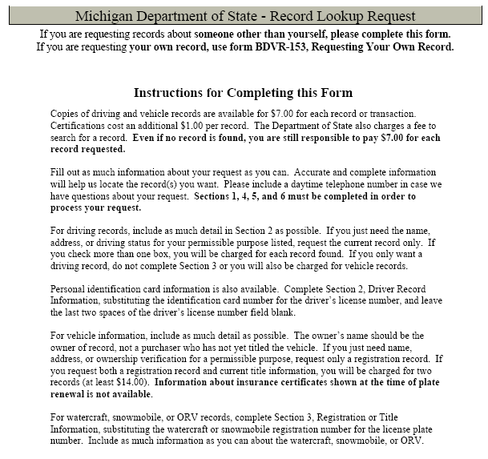

Michigan Department of State – Record Lookup Request
If you are requesting records about someone other than yourself, please complete this form.
If you are requesting your own record, use form BDVR-153, Requesting Your Own Record.

SECTIONS 1, 4, 5, AND 6 MUST BE COMPLETED IN ORDER TO PROCESS YOUR REQUEST FOR RECORDS.

Section 1. Requestor (Please print or type all information.)
Requestor Name (Individual or Company)  Axiom Requisition Copy Service |  |  |  |  |  |  |  |  |  |  |  |  |  |  |  |  |  | Agent’s Name and Title (if company)  Leah D. Boroski, Account Executive
Mailing Address  2869 Jolly Rd |  |  |  |  |  |  |  |  |  |  |  |  |  |  |  |  |  |  |  |  |  |  |  |  |  |  |  |  |  |  |  |  |  |  |  |  | File or Claim Number
City  Okemos |  |  |  |  |  |  |  |  |  |  | State  Michigan |  |  |  |  |  | Zip  48864 |  |  |  |  |  |  |  |  |  |  |  |  |  |  |  |  |  |  |  | Daytime Telephone Number  (877) 886-5090
Section 2. Driver Information (If you only want a driving record, leave Section 3 blank.)
☑ Driving Record for:  (Showslast reported address)  - Employment or Insurance  - Court  ☑ Other: Legal Matter |  |  |  |  |  |  |  |  |  |  |  | ☑ Current Application or Application History*  from ______/______/________ to ______/______/________  ◻ Address History*  from ______/______/________ to ______/______/________
Driver’s Full Name (First, Middle, Last) |  |  |  |  |  |  |  |  |  |  |  | Driver’s License Number  08/15/1964 |  |  |  |  |  |  |  |  |  |  |  |  |  |  |  |  |  |  |  |  |  |  |  |  |  |  |  |  | Birth Date
Shelley Marie Pittman
Driver’s Full Name (First, Middle, Last) |  |  |  |  |  |  |  |  |  |  |  | Driver’s License Number |  |  |  |  |  |  |  |  |  |  |  |  |  |  |  |  |  |  |  |  |  |  |  |  |  |  |  |  | Birth Date
Section 3. Registration or Title Information (Insurance information is not available.)
Note: $7.00 is charged for each transfer or transaction found. Complete histories can be expensive.
(If you only need a driving record, leave the registration or title information blank or you will be charged for both records.)
License Plate or  Registration Number |  |  |  |  |  |  | Vehicle  Year |  | Make and Model |  |  |  |  |  |  | Vehicle or Hull Identification Number
◻ Current Vehicle Owner and  Lienholder Information  ☑ Copy of Current Registration |  |  |  |  |  |  |  |  |  | ◻ Copy of Current Title Application and Related Forms  ◻ Complete Title History*  ◻ Partial Title History*  ◻ Partial Registration History* |  |  |  |  |  |  |  |  |  |  |  |  |  |  |  |  |  |  |  |  |  |  |  |  | Check box if you want:  ☑ All motor vehicles registered  or titled to this owner.**  ◻ All other registered or titled  assets for the owner indicated.**
For partial histories, please complete: from ______/______/________ to ______/______/________
Owner(s) Name
Shelley Marie Pittman
Owner(s) Address
2020 Peachtree Road, NW
City  Atlanta |  |  |  |  |  |  |  |  |  |  |  |  |  |  |  | State  Michigan |  |  |  |  |  |  |  |  |  |  |  |  |  |  |  |  |  |  |  |  |  |  |  | Zip  30309-1465
* Buying a complete or partial title, application, and/or address history can be very expensive. The $7.00 fee is charged for each address or title change or correction. If you need the last owner, just request the previous title.  ** When requesting records for all motor vehicles or all assets registered and/or companies, precise information is required. Information retrieved is based upon an exact name and address match. The individual’s name and address, as provided by the record requestor, , must match the name and address on the record(s) held by the Michigan Department of State. |  |  |  |  |  |  |  |  |  |  |  |  |  |  |  |  |  |  |  |  |  |  |  |  |  |  |  |  |  | For Office Use Only
 |  |  |  |  |  |  |  |  |  |  |  |  |  |  |  |  |  |  |  |  |  |  |  |  |  |  |  |  |  | BDVR-154-WEB (08/03)

Order No. 01-12022 - 019
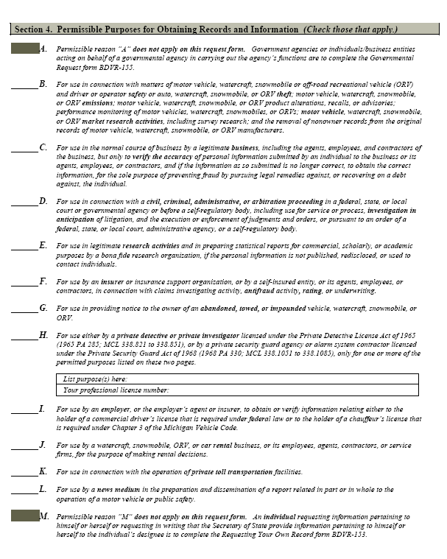
X
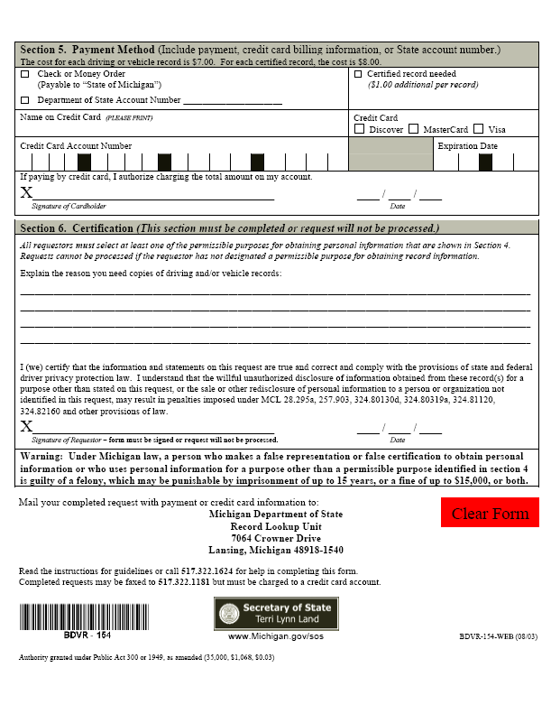
Legal Action of Pittman v. Jamil, M.D.

